CTM-I Use Case

Dynamic Parm Browse

Version 0.1

Use Case Name | Dynamic Parm Browse
Actor | App Support
Pre-conditions /Assumptions | User has selected a Parm Definition to browse by on the Parm Browse.
Post Conditions | None
Screenshot | 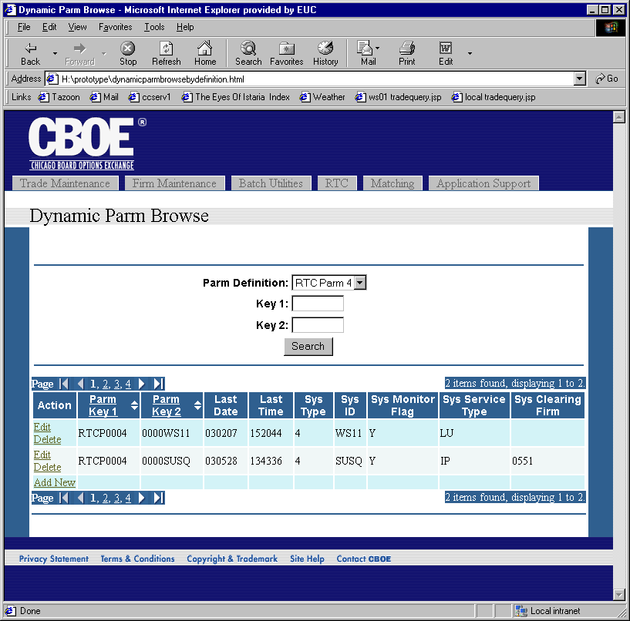
Flow of Events | - The specified Parm Definition is retrieved from CTM-R.  - A request is made to CTM-R to retrieve all the records that match the key criteria for the Parm Definition, Key 1 and Key 2.  - Results of the CTM-R processing are displayed on the Dynamic Parm Browse screen  - Criteria used for the search will show in the top part of the screen.  - The criteria fields will default with the values used to search.  - Parms matching the criteria will show on the bottom of the screen in table format.  - The table will have the standard paging mechanism.  - The table will display the following static fields  - Parm Key 1  - Parm Key 2  - Last Date  - Last Time  - The table will display the each of the fields setup in the Parm Definition and their value for each Parm. The fields will be dynamic and change with the Parm Definition selected. Only one Parm Definition can be selected.  - The table will be sortable by “Parm Key 1” and “Parm Key 2”  - An Edit action will display for each parm in the table. Activating the edit action will trigger one of the Dynamic Parm Use Cases. If the Parm Definition is not linked, the Dynamic Parm Edit Use Case is activated. If the Parm Definition is linked, the Dynamic Parm Edit Linked Use Case is activated.  - A delete action will display for each parm in the table. Activating the delete action will first give the user a confirmation pop-up, then request CTM-R to delete the parm. The search will be executed and the results displayed.  - An Add New action will be displayed. Activating the Add New action will trigger the Dynamic Parm Add Use Case.
Alternative Path

